General Notes:
Your blueprint is a gateway to knowledge and insights about your solution. Think of it as a high-level recipe book, made to inform action-takers who will replicate what you achieved elsewhere. Your blueprint is a stand-alone documents, with links to further knowledge resources.
Your reader should be able to identify (i) what the solution is, (ii) why it could be applied, (iii) the different elements involved in applying it, and (iv) things to watch out for.
Once they’ve read it, they should be clearly aware of what the solution is, and how they can make a start. They should be briefed enough to continue on to more detailed documentation, and communicate with other groups with the correct words to use in their enquiries.
When writing this, think ingredients (e.g. what they need to have in place to make a good start), and activities (what they will need to do with the ingredients). Your blueprint’s job is to engage people, invite them to know more, and equip them with the basic knowledge they need to determine whether this is a solution they could find a use for.

Tips and Tricks:
- We would suggest font size 12, or 11, just to make sure you actively keep the text brief.
- Images / visualisations should take up between 30-50% of the body text space.
- Any text in the imagery/visuals should be clearly legible.
- Images should NOT have captions - they should be self-explanatory.
- Top tip: As you finish a page, visualise it at 100% from your computer screen, and take a step back to 1-2m from your screen. If you cannot read it, the font is too small.
- Have a key contact person for your solution – someone who knows the general terms, and can connect the interested person to others who know about the more detailed areas.
- Think of your blueprint as a gateway, to more information and knowledge about the solution. More detailed information can be found elsewhere, while this blueprint contains a higher-level, more introductory overview to the solution, its context, what is involved, and what people need to think about doing.
- Consider getting someone with graphic design experience to make it look pleasing to the eye and visually interesting. This template helps you to bring together the content, with an investment in visuals helping you to engage people with the document and invite them to learn about your solution.

TITLE PAGE
e.g. Digital stakeholder engagement for local change: Promoting understanding, fostering a sense of responsibility, driving behavioural change

Make this entire cover page eye-catching, maybe include an infographic, or design that tells the casual reader what your solution involves. The idea here is to invite them to turn the page and find out more.

Key Message
This is critical – what are the two or three key things you want someone to remember from reading your blueprint.
e.g.
- Coastal erosion is a natural process, but human activity and climate change are worsening its impacts
- Empowering communities and managers with data and awareness is critical.

Policy Relevance
If there is any buy-in needed from local, regional or national authorities, giving them the policy relevance of your actions is very helpful. It helps them see the why and what your activity helps them deliver on. Think of the Sustainable Development Goals, or European Policies that expect to see regional and local action delivering them.
e.g. E.U. Strategy on Adapting to Climate change, E.U. Floods Directive (2007/60/EC), etc.

What is the Challenge?
This is the Solution Rational – keep it brief, clear and concise. Start with the big issue, and then narrow it down to the key gaps that your solution addresses. Try to avoid being too negative! Focus on framing your solution.
e.g. About a quarter of all European coastlines have been modified because of human activities. Intense anthropomorphisation of coastal areas has destroyed natural habitats, leading to a significant loss of biodiversity, while unbalancing existing ecosystems. Artificially increasing the rugosity of the underwater landscape in Ports and Marinas lays down much-needed substrate for restoring the coastal underwater ecosystem.

An innovative solution
Propose the heart of your solution, describing it at a high level. In no more than three sentences, outline what it is, what it involves and what it does. This is not easy!
Think of putting an image here, with some key facts/figures on the issue this solution tackles.
e.g. Deploying Artificial Fish Nurseries (AFNs) in Ports and Marinas provides a home for local benthic species to settle on, while providing shelter and food for young fish. Meanwhile, active acoustic recruitment may boost initial colonization of the Artificial Fish Nurseries. From this healthy, diverse and protected environment, local fish communities are supported to thrive and repopulate the impacted coastal areas.

What is this innovative solution?
1 headline sentence which captures what is the heart of your solution. This will not be easy for most. Follow this with two to three sentences on what is involved when implementing the solution - basically a high level overview of the ingredients, and the activities involved in making it a reality - these are expanded on below.
Think of putting an image here, an image that captures some key aspect of the solution. If possible source this image from your actual solution.
e.g. it could be:
- An example of the hiking lead talking to people about the land in Norway, or
- a camera shot of the beach in use at Inchydoney, or
- people using the Bird hide in Harpers island, or
- people talking and discussing, with a visible facilitator, or
- people playing the game learning abut sustainable cooperation
- etc.
e.g. The solution embeds community-led protection of a key predatory species to support rebuilding damaged ecosystems.
As full restoration of an ecosystem in one move is difficult, rebuilding a key player in the ecosystem is a cost efficient and realistic first step. The selected key predatory species has limited commercial value and is mainly caught as bycatch – and have high survival rate if released after being caught. By implementing restrictions in collaboration with the local community, we expect a significant reduction in fishery mortality. Engaging and educating school children facilitates a long term sustainable solution.

The Benefits the solution produces
A Short set of bullet points highlighting what the solution activates or enables by it’s implementation
e.g.
If you have any data that shows your solution works, visualise it here.
Otherwise, perhaps a key stakeholder quote can go here.
e.g. 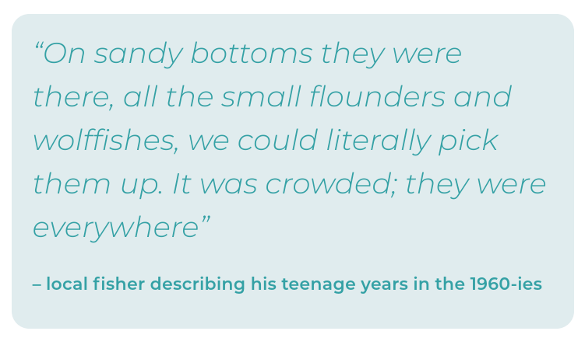
- Marine restoration through behavioural change and empowerment of people to
adopt pro-environmental behaviours.
- Rebuilding a depleted fish: increase biodiversity and enhance fisheries in the long term.

How developed is the solution.
This gives your readers an idea of how well tested and verified your solution is. Try looking at the Social Readiness Level scale, and use that as a guide. All solutions, whatever their tested level, are useful. This just gives your readers of how ground-breaking you are being.
e.g.” The solution is at an advanced stage of readiness, combining fully validated core activities with an integrative digital interface currently under testing. Key components, including the maritime carbon footprint calculator, biofuel testing in recreational boating, and seagrass restoration protocols, have been implemented and validated in real-world conditions. These activities are now being brought together through an interactive interface that integrates emissions data, fuel substitution options, and blue carbon restoration metrics, enabling joint exploration of impacts and trade-offs. The interface is undergoing functional and usability testing within participatory settings and will be embedded in the A-AAGORA Digital Knowledge System, allowing iterative improvement, interoperability, and scalability across regions”

Where could the solution also be applied to?
Here, mention the key characteristics of the area and context that made the regions suitable for your solution to be developed and deployed. These could be physical, geographical, political, sociological or even economic. In A-AAGORA, we outlined both the area characteristics, and the Intention for applying this solution (why did we want to use this particular approach). This helps people understand the context, and see what similarities lie between their area and yours.
e.g.” The solution is at an advanced stage of readiness, combining fully validated core activities with an integrative digital interface currently
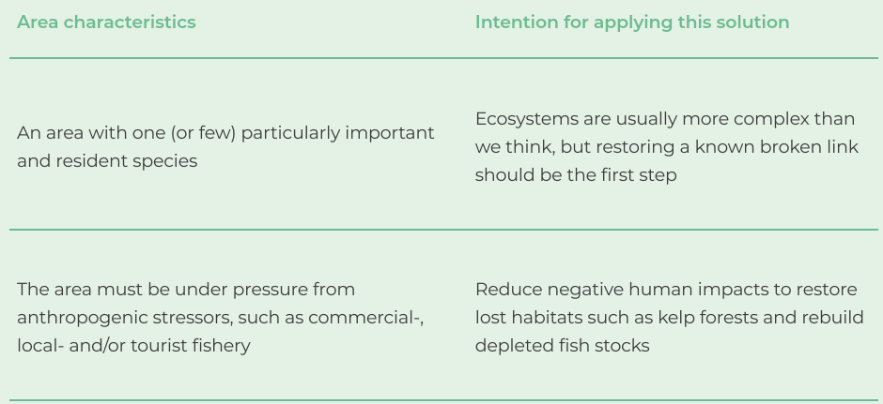

Who is this relevant to?
Help people see whether they could be an action-taker to use your solution. Giving them keywords that describe your intended target audience is really helpful here.
e.g. :
Local community
• Fishers
• Tourist businesses
• Local and national authorities

What do you need to have in place:
This is effectively your ingredients list – what do you need to have on the table before you begin. People can use this section to look at the area, figure out what they need to address beforehand, and get the right context in place for the solution to be deployed at a later time.
e.g.:
A graphical representation of your solution and it’s key components (as in what ingredients do you need).

Make sure it complements the text.
“Before you dive into implementing this solution, it is worth having, or establishing, the following key things in your area:
• Identify the problem. Include its possible causes and identify a candidate species that should be rebuilt (potential key species)
• A local community who care for, and recognise the importance of healthy ecosystems
• Highly motivated contact persons to build bridges between the local community, local authorities (e.g. the municipality) and scientists Key components:

Key components of implementation:
This is the activities list that deliver the solution itself. Any solution involves a number of activities and parts. A top tip here is to pair a headline action, with a description. Present your components as a list, starting each headline with a verb (i.e. Do X. Why; see e.g.) if possible, though there are a range of alternatives that work, such as grouping activities together and giving them a headline identifier (e.g. 2)
e.g 1:
- “Map the stakeholders. Who are the users of the area (including economic interests in current and future scenarios) and who have the proper tools to induce changes on local, regional and national levels.”
e.g. 2:
- “Coastal monitoring: You will need to observe and characterise the dynamics occurring in the target coastline, understanding the goal of your restoration intervention. This may involve developing beach character baselines using GPS surveying (collecting representative beach profiles), setting up video monitoring of the coastline in question, or engaging citizens in the data collection process through the use of Public Participatory Geographical Systems. Characterising the dynamics of your coastline will help you identify when extremes are experienced, and rationalise when interventions are needed. Video monitoring can also support coastal warning systems where appropriate (see below). Key elements are:
  - GPS surveying to develop a beach character baseline
  - Establish video monitoring
  - Public data gathering / citizen science”

Monitoring your success
Monitoring the impact of your solution and gathering evidence on how effectively, and how it works is critical to help convince people your solution is a viable use of their time and effort. To be effective, and cost efficient, you need to plan how you are going to do this. Here, identify the things you think should be monitored (and suggest how) so people can think and develop proxies that work for their local context.
e.g 1.
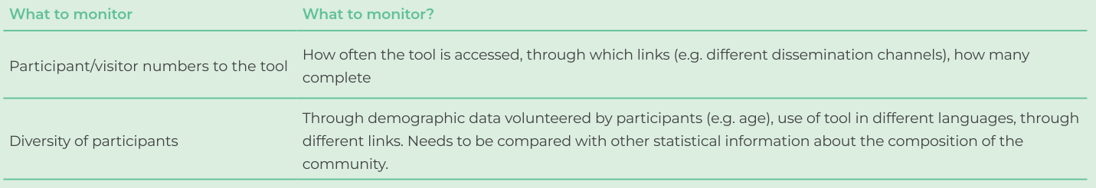
e.g. 2:
“It is very important to monitor your AFNs and the impact they have on the local environment and citizens perspectives/awareness. Here is a list of the main things you should think about monitoring:
- AFN integrity: Ensure the installed Artificial Fish Nurseries are not damaged by weather factors like waves and currents nor by local activities.
- Ecological Succession progress: Here, you can observe and record information on:
- Colonization, by fast-growing opportunistic species like barnacles, bryozoans, sponges, polychaetes.
- Growth and Succession, by slower-growing but more competitive species like massive sponges, large macroalgae, and corals.
- Attraction of Mobile Fauna like fish, crustaceans, molluscs, and other mobile species that are attracted by shelter and food.”
e.g. 3:
“Monitoring and adapting solution activities over time is critical for maximising impact. Monitoring focuses on technical performance, climate outcomes, governance effects, and user engagement, recognising the digital interface as the core enabler of integration and co creation. Key indicators include:
- Governance and Knowledge Co-Production
  - Stakeholder collaboration: Number and diversity of joint actions, agreements, or initiatives supported through the platform.
  - Policy Uptake: Evidence of integration of outputs into local, regional, or sectoral climate and biodiversity strategies.”

Costs and timeframes
People interested in your solution need to get an idea of how much this would cost, and how long would it take. However, this is very regionally-specific, and the costs across so many various component activities are complex. As a blueprint provider you need to capture the flexibilities but inform people a flavour of what to expect, and let them know the issues that can increase costs. Below is an example of how to do this.
There are two parts to this section:
Part 1 – the costs and timeframes involved.
You could use a simple project management technique as we used below for estimating costs, and cost ranges. Then present them in more high-level terms.
$$C_{n}=\frac{C_{b}+C_{w}+{3C}_{g}}{5}$$
$C_{n}$ is the cost figure you are looking for – approximately how much could this cost
$C_{b}$ is the best case scenario – the cost when everything goes correctly and according to plan
$C_{w}$ is the worst case scenario – what happens when everything goes wrong, delays are everywhere but you do eventually deliver the solution
$C_{g}$ is the general situation – In general, what is the cost noting that somethings do go wrong usually.
Top Tips:
- Start with $C_{b}$ , then estimate $C_{w}$ and only then estimate $C_{g}$.
- Remember this is a loose estimate, you are just giving your audience a rough estimate of what’s involved.
- Replace $C_{}$ with $T_{}$ for Time, and use the same formula to get an estimate of the timeframes involved.
Then convert your more specific numbers to general low, medium and high framings, presenting these. When you are looking at something such as cost range, or timeframe range, simply use the word associated with your best case scenario estimate, and your worst case scenario estimate.
e.g.
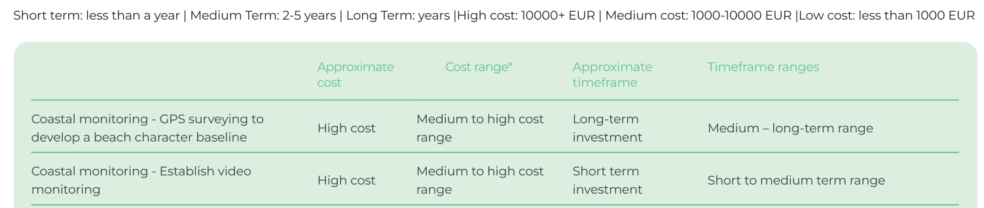

e.g. 2
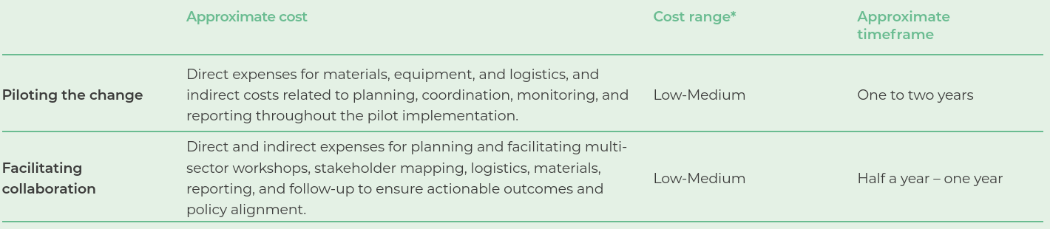

Part 2 – advice on what to watch out for that could increase costs or timelines.
Here, for each of your activities, make a list of things that led you to formulate your worst case scenario estimate. These constitute potential challenges people may encounter, and highlighting these to readers is very much appreciated by your audience.
e.g. 1
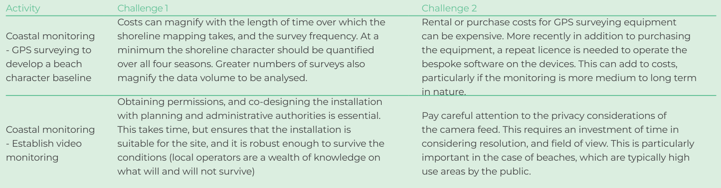
e.g.2
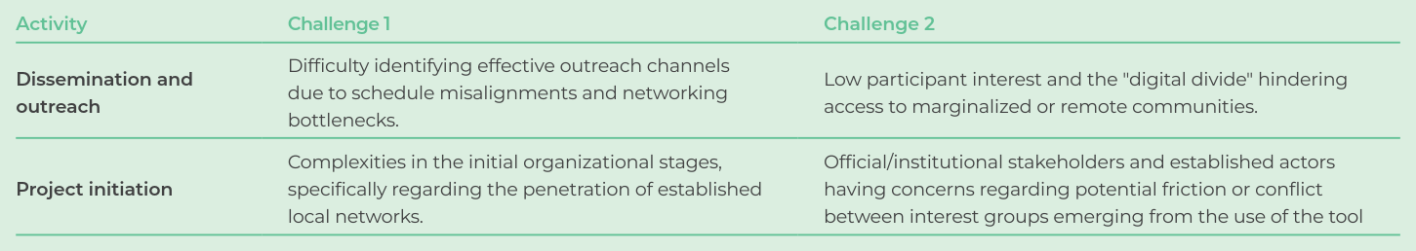
e.g.3

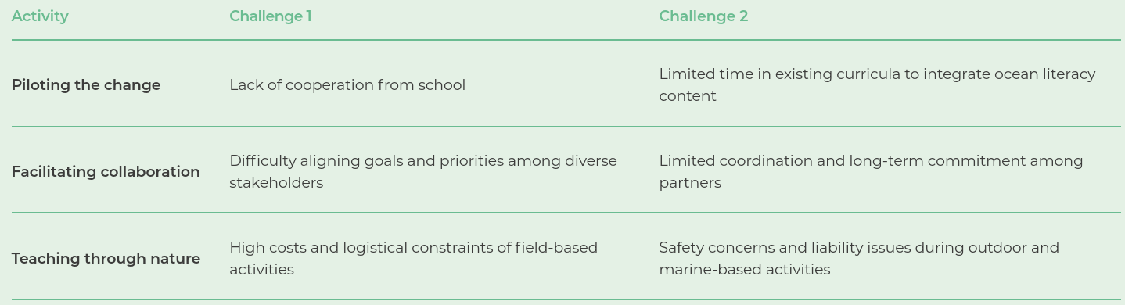

Key Contact – who to talk to about your application idea
It is wise to consider the value of having a person for someone to talk to and talk through their application idea. Here, provide someone who is well versed in your solution and who can at a minimum understand the context of the conversation and link them to people who know more about the various aspects. It is good to provide a name, and an organisation.
e.g.
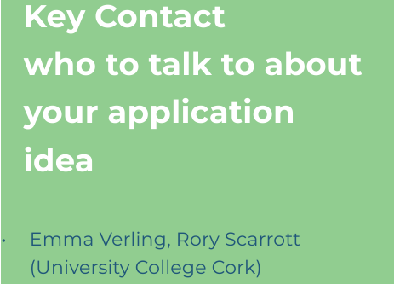

Further information (reading/resources box)
Organisation Always welcome, think of your Blueprint as a gateway to further knowledge about your solution. This section can be used to link people to protocols, best practice guidelines, published papers etc., which give more detail on your solution and how it works.
e.g.
- Mary, J.G. (2017) Approaches to talking to people. Journal of Conversations and Niceness, 293(2), 34-70.
- Norderhaug, K. M., Nedreaas, K., Huserbråten, M., & Moland, E. (2021). Depletion of coastal predatory fish sub-stocks coincided with the largest sea urchin grazing event observed in the NE Atlantic. Ambio, 50(1), 163-173. DOI: https://doi.org/10.1007/s13280-020-01362-4.[ Last accessed 28 Oct 2025.]
- Digital mobile games for educational purposes https://aaappetizer.a-aagora.eu
- Ocean Literacy book for children aged 4 to 10 years old - https://a-aagora.eu/resources/childrens-book/
- Stevenson-Jones, S., Bouchoucha, M., Daban, P., Elnagar, N., Ezgeta-Balić, D., Kakouli, C., Laranjeiro, D., Lennert, A., Levya, L., Lillebø, A., Øverjordet, I., Setsaas, L. & Verling, E. (2025). Explore the Ocean with Clio. [E-book]. A-AAGORA & CLIMAREST Key Contact Projects. E-ISBN 978-989-99524

